**SHIMONI DEMONSTRATION SCHOOL- KIRA**

**MID TERM TWO EXAMINATIONS, 2023**

**BABY CLASS HEALTH HABITS**

**Name ____________________________________________________**

1. Colour the tongue.

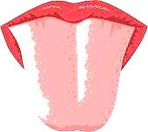

1. Match the same pictures.

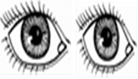 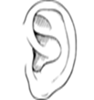

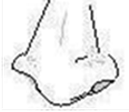 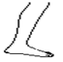

 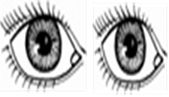

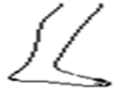 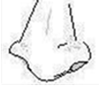

1. Colour these clothes

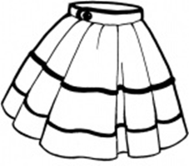 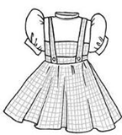

1. Match the same dangerous objects.

